**Muhammad Harith Bin Zainudin**

**192171**

**Lab Practice 5**

1. The HR wants to know how many departments with unique name are available in the company.

**Answers:**

*select department_name, count(department_name)*

*from departments*

*group by department_name*

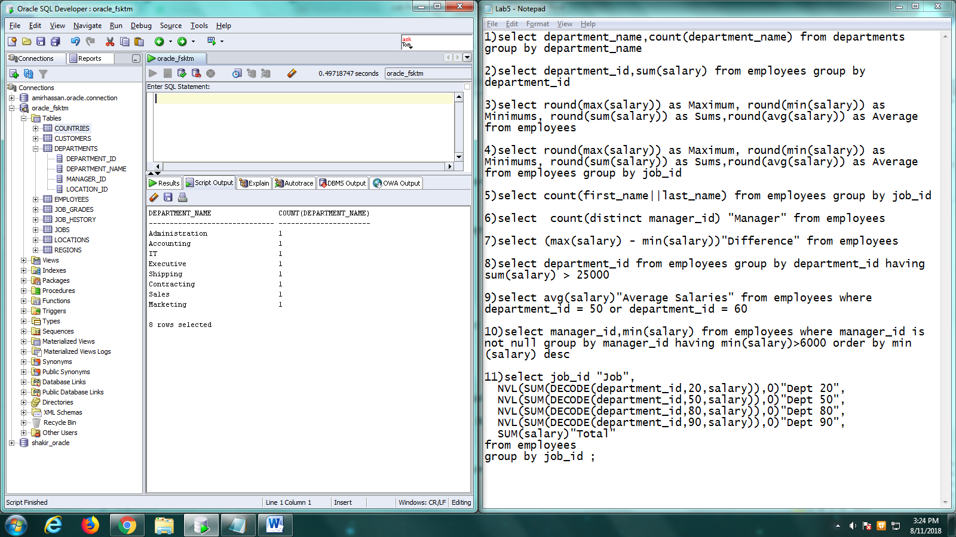

1. Create a report to display the department id and total amount of salary spent/paid on each department.

**Answers:**

*select department_id, sum(salary)*

*from employees*

*group by department_id*

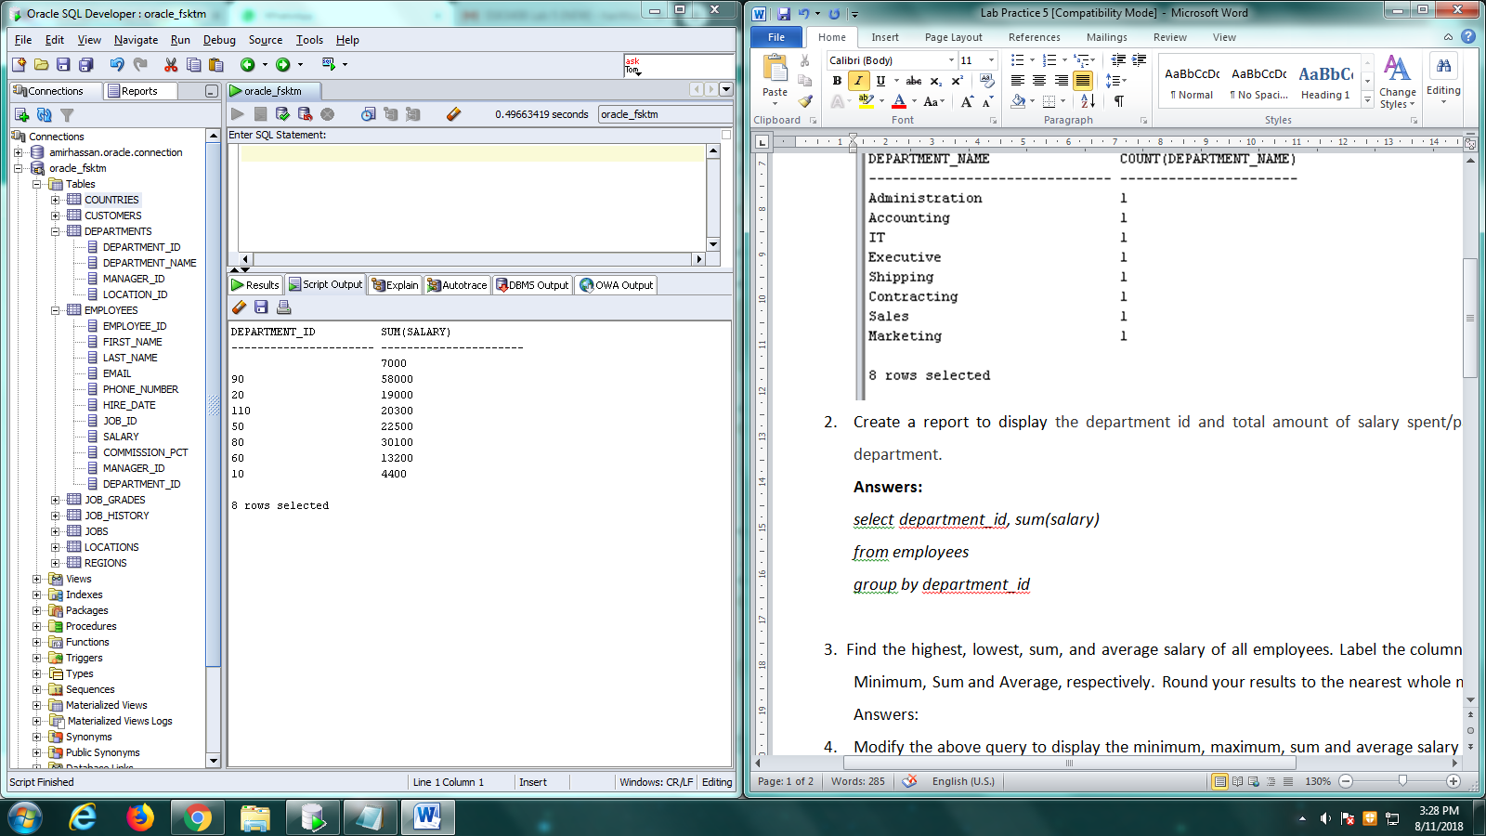

1. Find the highest, lowest, sum, and average salary of all employees. Label the columns Maximum, Minimum, Sum and Average, respectively. Round your results to the nearest whole number.

**Answers:**

*select round(max(salary)) as Maximum, round(min(salary)) as Minimum, round(sum(salary)) as Sums, round(avg(salary)) as Average*

*from employees*

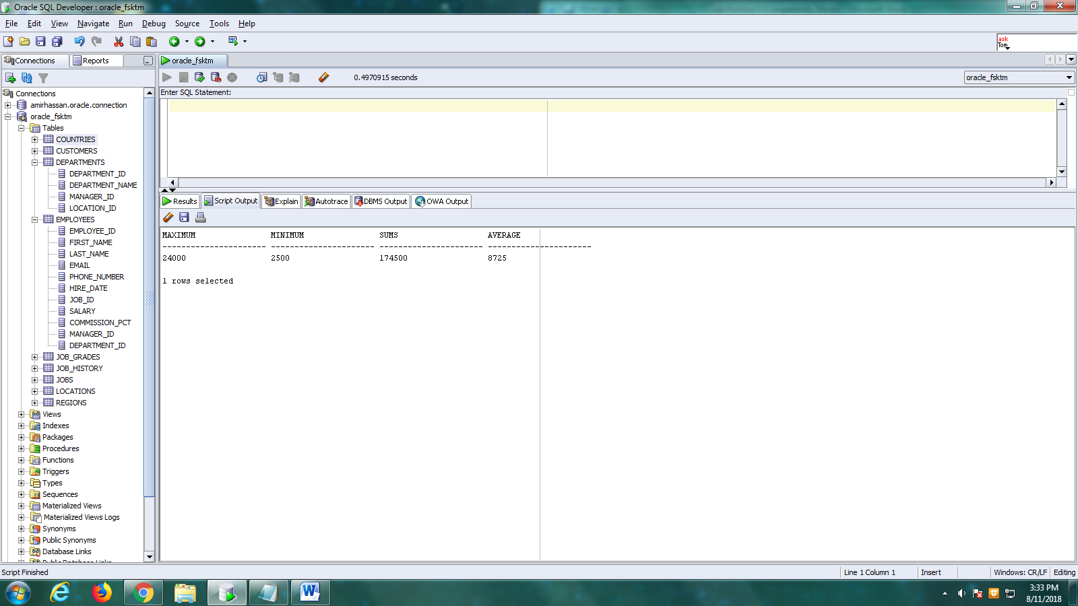

1. Modify the above query to display the minimum, maximum, sum and average salary for each job type.

**Answers:**

*select round(max(salary)) as Maximum, round(min(salary)) as Minimum, round(sum(salary)) as Sums, round(avg(salary)) as Average*

*from employees*

*group by job_id*

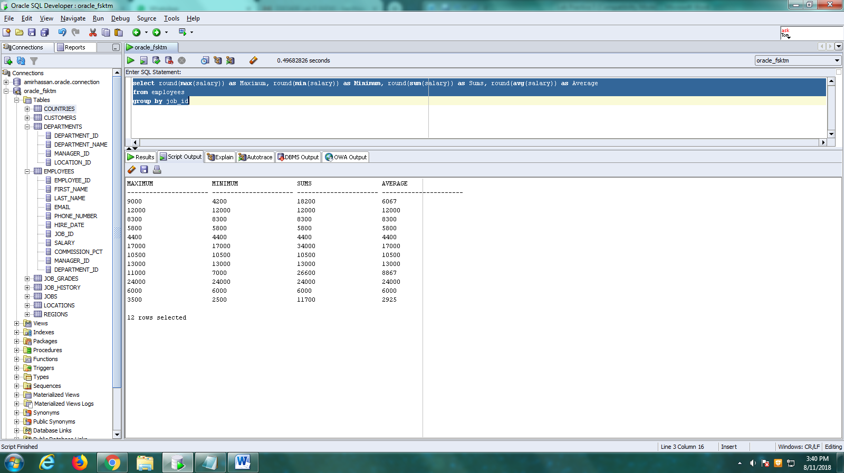

1. Write a query to display the number of people with the same job id.

**Answers:**

*select job_id, count (job_id) as "number"*

*from employees*

*group by job_id*

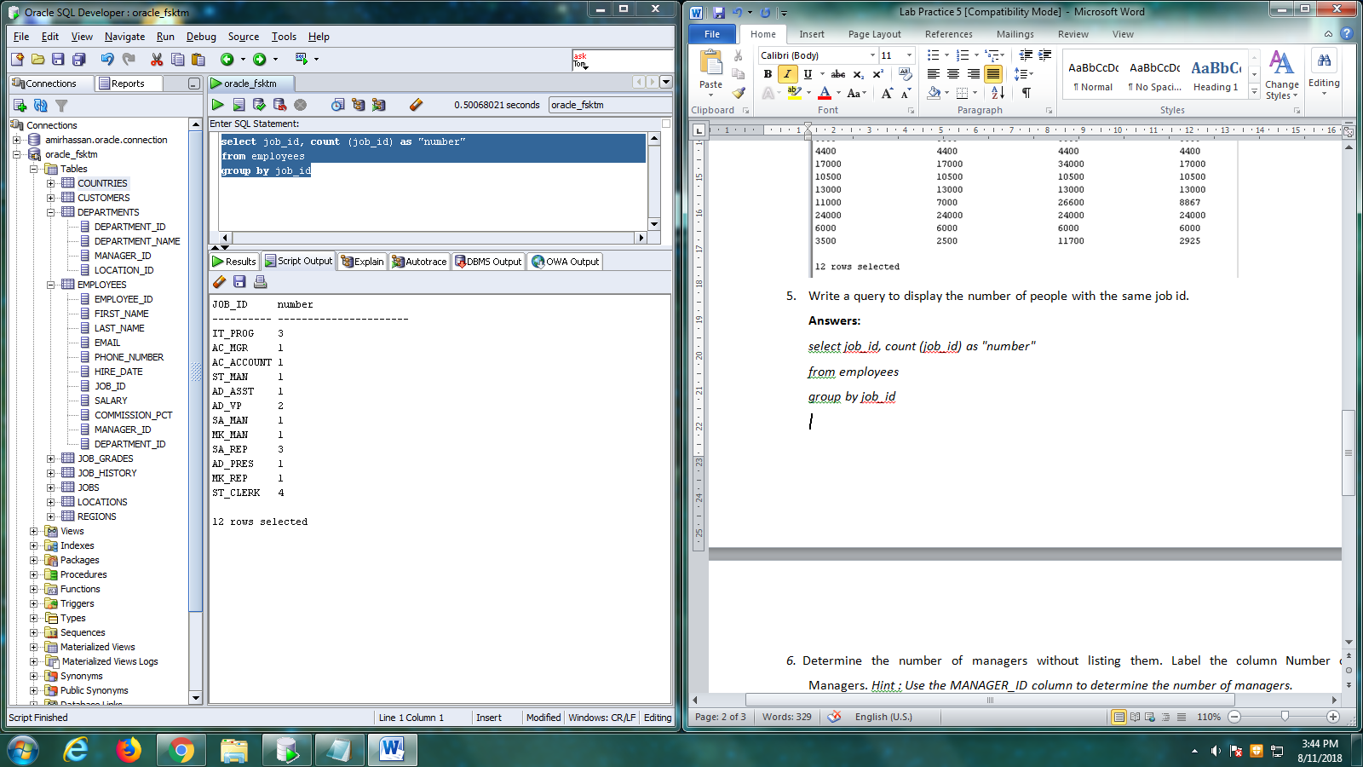

1. Determine the number of managers without listing them. Label the column Number of Managers. *Hint : Use the MANAGER_ID column to determine the number of managers.*

**Answers:**

*select count (distinct manager_id) as "manager"*

*from employees*

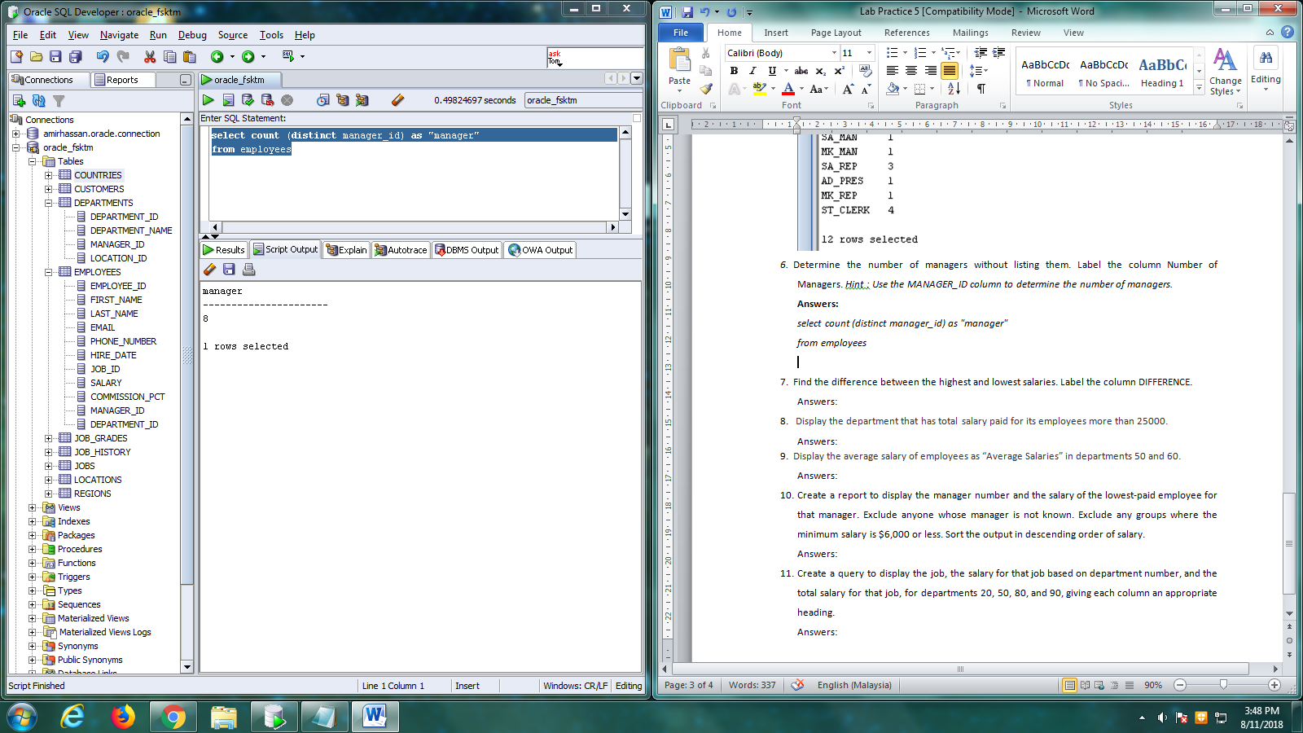

1. Find the difference between the highest and lowest salaries. Label the column DIFFERENCE.

**Answers:**

*select (max(salary) - min(salary)) as "DIFFERENCE"*

*from employees*

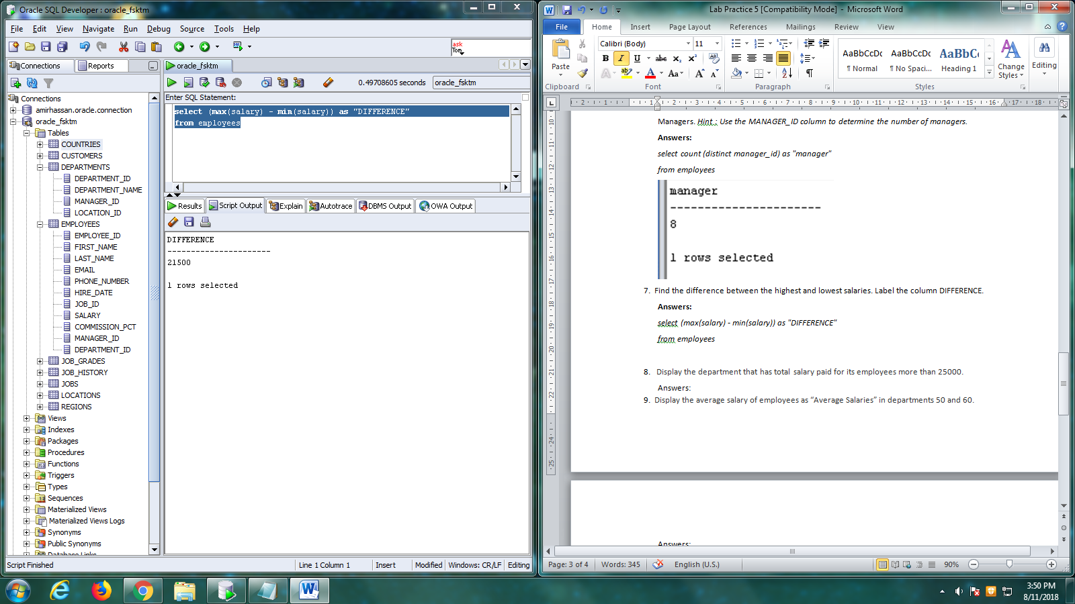

1. Display the department that has total salary paid for its employees more than 25000.

**Answers:**

*select department_id*

*from employees*

*group by department_id having sum(salary)>25000*

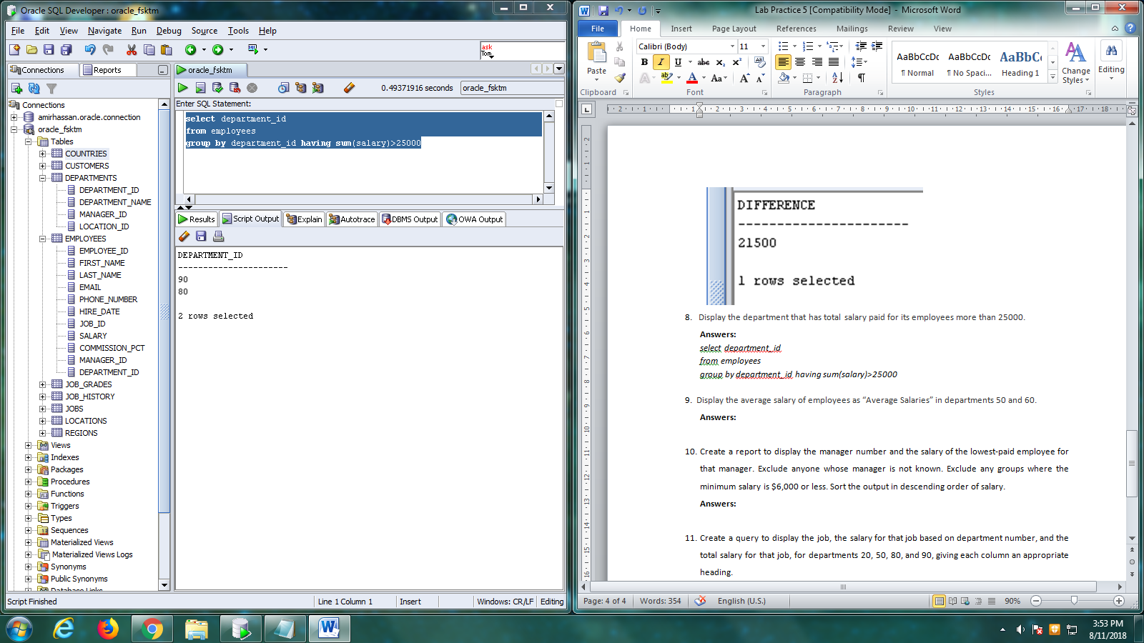

1. Display the average salary of employees as “Average Salaries” in departments 50 and 60.

**Answers:**

*select avg(salary) as "Average Salaries"*

*from employees*

*where department_id=50 or department_id=60*

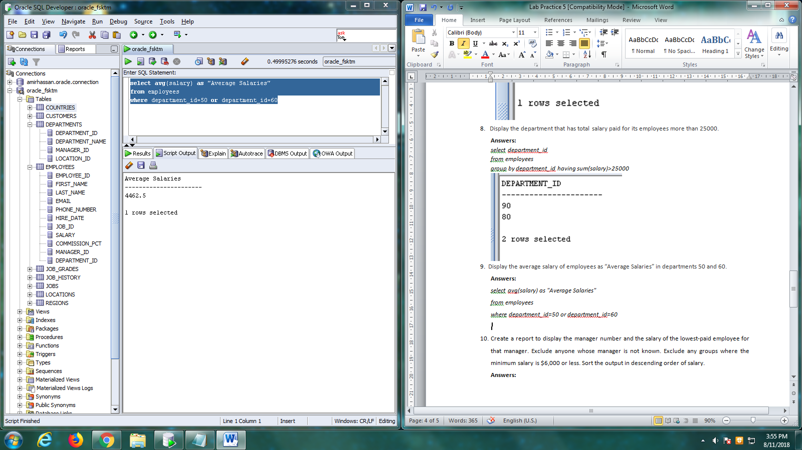

1. Create a report to display the manager number and the salary of the lowest-paid employee for that manager. Exclude anyone whose manager is not known. Exclude any groups where the minimum salary is $6,000 or less. Sort the output in descending order of salary.

**Answers:**

*select manager_id, min(salary)*

*from employees*

*where manager_id is not null*

*group by manager_id having min(salary)>6000*

*order by min(salary) desc*

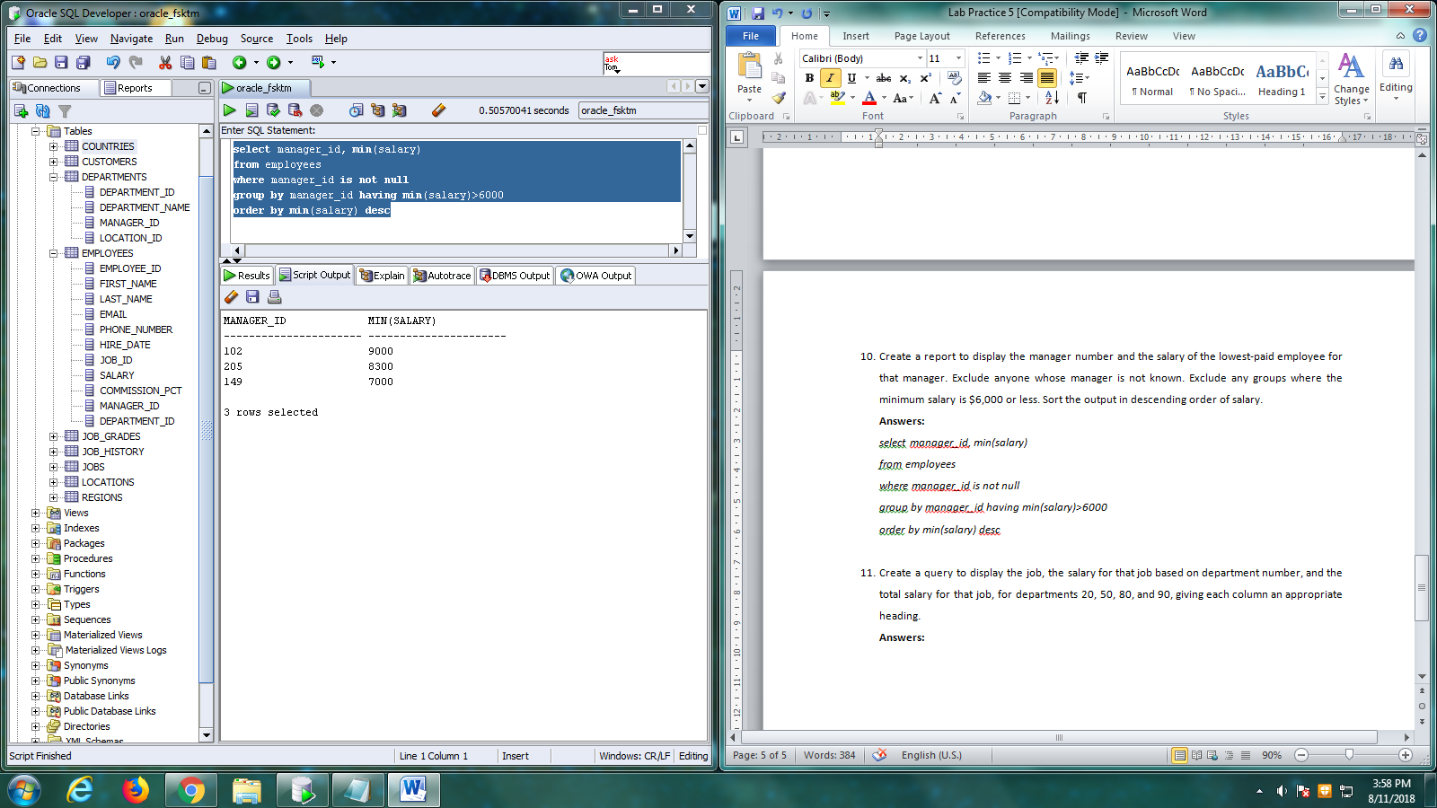

1. Create a query to display the job, the salary for that job based on department number, and the total salary for that job, for departments 20, 50, 80, and 90, giving each column an appropriate heading.

**Answers:**

*select job_id as "Job", NVL(SUM(DECODE(department_id,20,salary)),0) "Dept 20", NVL(SUM(DECODE(department_id,50,salary)),0) "Dept 50",NVL(SUM(DECODE(department_id,80,salary)),0) "Dept 80",NVL(SUM(DECODE(department_id,90,salary)),0) "Dept 90", sum(salary) as "Total"*

*from employees*

*group by job_id*

